**Practical -13: Tower of Honai**

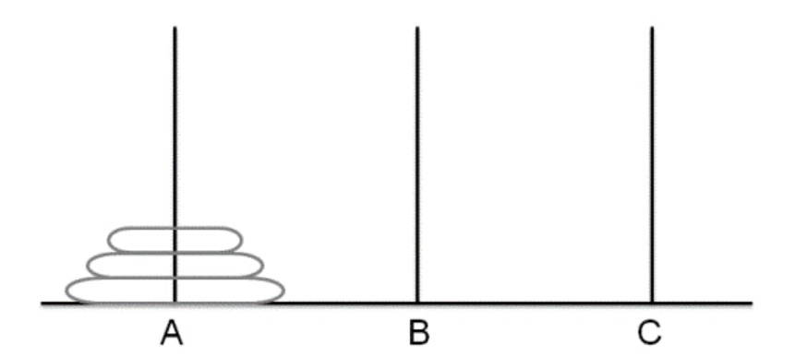

**Code:**

def tower_of_hanoi(n, source, destination, auxiliary):

if n == 1:

print(f"Move disk 1 from {source} to {destination}")

return

# Move n-1 disks from source to auxiliary, so they are out of the way

tower_of_hanoi(n - 1, source, auxiliary, destination)

# Move the nth disk from source to destination

print(f"Move disk {n} from {source} to {destination}")

# Move the n-1 disks that we left on auxiliary to destination

tower_of_hanoi(n - 1, auxiliary, destination, source)

# Number of disks

n = 3

tower_of_hanoi(n, 'A', 'C', 'B')

**Output:**

